LINEAR REGRESSION
Linear regression is one of the easiest and most popular Machine Learning algorithms. It is a statistical method that is used for predictive analysis. Linear regression makes predictions for continuous/real or numeric variables such as sales, salary, age, product price, etc.
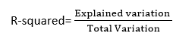
y= a0+a1x+ ε Here,
Y= Dependent Variable (Target Variable) X= Independent Variable (predictor Variable) a0= intercept of the line (Gives an additional degree of freedom) a1 = Linear regression coefficient (scale factor to each input value). ε = random error

1) Types of Linear Regression
Linear regression can be further divided into two types of the algorithm:

Simple Linear Regression:
If a single independent variable is used to predict the value of a numerical dependent variable, then such a Linear Regression algorithm is called Simple Linear Regression.

Multiple Linear regression:
If more than one independent variable is used to predict the value of a numerical dependent variable, then such a Linear Regression algorithm is called Multiple Linear Regression.

2) Linear Regression Line
A linear line showing the relationship between the dependent and independent variables is called a regression line. A regression line can show two types of relationship:

Positive Linear Relationship:
If the dependent variable increases on the Y-axis and independent variable increases on X-axis, then such a relationship is termed as a Positive linear relationship.

Negative Linear Relationship:
If the dependent variable decreases on the Y-axis and independent variable increases on the X-axis, then such a relationship is called a negative linear relationship.

Finding the best fit line:
When working with linear regression, our main goal is to find the best fit line that means the error between predicted values and actual values should be minimized. The best fit line will have the least error.
The different values for weights or the coefficient of lines (a0, a1) gives a different line of regression, so we need to calculate the best values for a0 and a1 to find the best fit line, so to calculate this we use cost function.

Cost function-
The different values for weights or coefficient of lines (a0, a1) gives the different line of regression, and the cost function is used to estimate the values of the coefficient for the best fit line. Cost function optimizes the regression coefficients or weights. It measures how a linear regression model is performing. We can use the cost function to find the accuracy of the mapping function, which maps the input variable to the output variable. This mapping function is also known as Hypothesis function. For Linear Regression, we use the Mean Squared Error (MSE) cost function, which is the average of squared error occurred between the predicted values and actual values. It can be written as:
Where,
N=Total number of observation Yi = Actual value (a1xi+a0)= Predicted value.

Residuals:
The distance between the actual value and predicted values is called residual. If the observed points are far from the regression line, then the residual will be high, and so cost function will high. If the scatter points are close to the regression line, then the residual will be small and hence the cost function.

Model Performance:
The Goodness of fit determines how the line of regression fits the set of observations. The process of finding the best model out of various models is called optimization. It can be achieved by below method:

R-squared method:
R-squared is a statistical method that determines the goodness of fit. It measures the strength of the relationship between the dependent and independent variables on a scale of 0-100%. The high value of R-square determines the less difference between the predicted values and actual values and hence represents a good model. It is also called a coefficient of determination, or coefficient of multiple determination for multiple regression. It can be calculated from the below formula:

Assumptions of Linear Regression

1) Linear relationship between the features and target:
Linear regression assumes the linear relationship between the dependent and independent variables.

2) Small or no multicollinearity between the features:
Multicollinearity means high-correlation between the independent variables. Due to multicollinearity, it may difficult to find the true relationship between the predictors and target variables. Or we can say, it is difficult to determine which predictor variable is affecting the target variable and which is not. So, the model assumes either little or no multicollinearity between the features or independent variables.

3) Homoscedasticity Assumption:
Homoscedasticity is a situation when the error term is the same for all the values of independent variables. With homoscedasticity, there should be no clear pattern distribution of data in the scatter plot.

4) Normal distribution of error terms:
Linear regression assumes that the error term should follow the normal distribution pattern. If error terms are not normally distributed, then confidence intervals will become either too wide or too narrow, which may cause difficulties in finding coefficients. It can be checked using the q-q plot. If the plot shows a straight line without any deviation, which means the error is normally distributed.

5)No autocorrelations:
The linear regression model assumes no autocorrelation in error terms. If there will be any correlation in the error term, then it will drastically reduce the accuracy of the model. Autocorrelation usually occurs if there is a dependency between residual errors.

Example 1
# import matplotlib.pyplot as plt
x = [5,7,8,7,2,17,2,9,4,11,12,9,6]
y = [99,86,87,88,111,86,103,87,94,78,77,85,86]
plt.scatter(x, y)
plt.show()
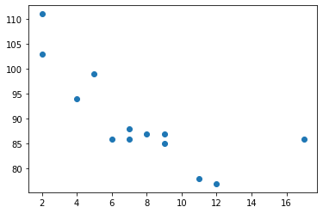

Import scipy and draw the line of Linear Regression:
import matplotlib.pyplot as plt
from scipy import stats
x = [5,7,8,7,2,17,2,9,4,11,12,9,6]
y = [99,86,87,88,111,86,103,87,94,78,77,85,86]
slope, intercept, r, p, std_err = stats.linregress(x, y)
def myfunc(x):
return slope * x + intercept
mymodel = list(map(myfunc, x))
plt.scatter(x, y)
plt.plot(x, mymodel)
plt.show()
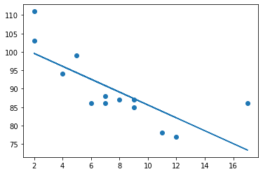

if there are no relationship the linear regression can not be used to predict anything.

This relationship - the coefficient of correlation - is called r.

The r value ranges from -1 to 1, where 0 means no relationship, and 1 (and -1) means 100% related.
from scipy import stats
x = [5,7,8,7,2,17,2,9,4,11,12,9,6]
y = [99,86,87,88,111,86,103,87,94,78,77,85,86]
slope, intercept, r, p, std_err = stats.linregress(x, y)
print(r)
-0.758591524376155

Predict Future Values
from scipy import stats
x = [5,7,8,7,2,17,2,9,4,11,12,9,6]
y = [99,86,87,88,111,86,103,87,94,78,77,85,86]
slope, intercept, r, p, std_err = stats.linregress(x, y)
def myfunc(x):
return slope * x + intercept
speed = myfunc(10)
print(speed)
85.59308314937454

Bad Fit?
Let us create an example where linear regression would not be the best method to predict future values.
import matplotlib.pyplot as plt
from scipy import stats
x = [89,43,36,36,95,10,66,34,38,20,26,29,48,64,6,5,36,66,72,40]
y = [21,46,3,35,67,95,53,72,58,10,26,34,90,33,38,20,56,2,47,15]
slope, intercept, r, p, std_err = stats.linregress(x, y)
def myfunc(x):
return slope * x + intercept
mymodel = list(map(myfunc, x))
plt.scatter(x, y)
plt.plot(x, mymodel)
plt.show()
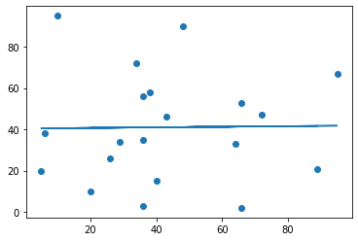

And the r for relationship?
import numpy
from scipy import stats
x = [89,43,36,36,95,10,66,34,38,20,26,29,48,64,6,5,36,66,72,40]
y = [21,46,3,35,67,95,53,72,58,10,26,34,90,33,38,20,56,2,47,15]
slope, intercept, r, p, std_err = stats.linregress(x, y)
print(r)
0.01331814154297491

The result: 0.013 indicates a very bad relationship, and tells us that this data set is not suitable for linear regression

Example 2
import numpy as np
import matplotlib.pyplot as plt
import pandas as pd
# Importing the dataset
dataset = pd.read_csv('salary_data.csv')
X = dataset.iloc[:, :-1].values #get a copy of dataset exclude last column
y = dataset.iloc[:, 1].values #get array of dataset in column 1st
dataset.head()
YearsExperience Salary
0 1.1 39343
1 1.3 46205
2 1.5 37731
3 2.0 43525
4 2.2 39891
# Splitting the dataset into the Training set and Test set
from sklearn.model_selection import train_test_split
X_train, X_test, y_train, y_test = train_test_split(X, y, test_size=1/3, random_state=0)
# Scaling
from sklearn.preprocessing import StandardScaler
sc_X = StandardScaler()
X_train = sc_X.fit_transform(X_train)
X_test = sc_X.transform(X_test)
# Fitting Simple Linear Regression to the Training set
from sklearn.linear_model import LinearRegression
regressor = LinearRegression()
regressor.fit(X_train, y_train)
LinearRegression()
# Fitting Simple Linear Regression to the Training set
from sklearn.linear_model import LinearRegression
regressor = LinearRegression()
regressor.fit(X_train, y_train)
# Predicting the Test set results
y_pred = regressor.predict(X_test)
print('R squared Train Score: ', regressor.score(X_train, y_train))
print('R squared Test Score: ', regressor.score(X_test, y_test))
R squared Train Score: 0.9381900012894278
R squared Test Score: 0.9749154407708353
from sklearn import metrics
y_test.shape
(10,)
y_pred.shape
(10,)
# R squared Error
train_error_score = metrics.r2_score(y_test, y_pred)
print("R squared Error - Training : ", train_error_score)
R squared Error - Training : 0.9749154407708353
import seaborn as sns
sns.regplot(y_test, y_pred, scatter_kws={"color": "green"}, line_kws={"color": "blue"})
C:\Users\user\anaconda3\lib\site-packages\seaborn\_decorators.py:36: FutureWarning: Pass the following variables as keyword args: x, y. From version 0.12, the only valid positional argument will be `data`, and passing other arguments without an explicit keyword will result in an error or misinterpretation.
warnings.warn(
<AxesSubplot:>
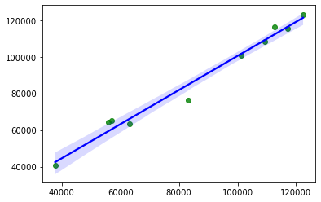
# Visualizing the Training set results
viz_train = plt
viz_train.scatter(X_train, y_train, color='red')
viz_train.plot(X_train, regressor.predict(X_train), color='blue')
viz_train.title('Salary VS Experience (Training set)')
viz_train.xlabel('Year of Experience')
viz_train.ylabel('Salary')
viz_train.show()
# Visualizing the Test set results
viz_test = plt
viz_test.scatter(X_test, y_test, color='red')
viz_test.plot(X_train, regressor.predict(X_train), color='blue')
viz_test.title('Salary VS Experience (Test set)')
viz_test.xlabel('Year of Experience')
viz_test.ylabel('Salary')
viz_test.show()
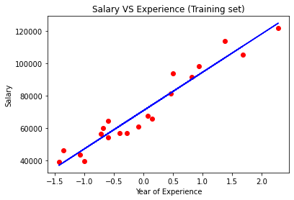
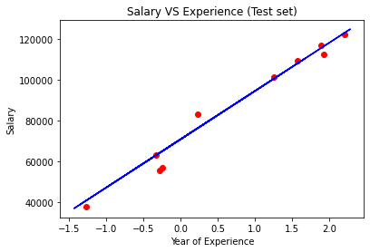
X_test.dtype
dtype('float64')
X_test[:10]
array([[-1.27636084],
[ 2.20103092],
[-0.24894964],
[-0.32798127],
[ 1.88490439],
[ 1.56877787],
[ 1.92442021],
[-0.28846545],
[ 0.22524015],
[ 1.25265135]])
# Predicting the result of 5 Years Experience
y_pred = regressor.predict([[5]])
print(y_pred)
[189278.22060006]

Example 3
# Importing Libraries
import numpy as np
import matplotlib.pyplot as plt
import pandas as pd
from sklearn import preprocessing
pre_process = preprocessing.StandardScaler()
# Importing USA Housing.csv
data = pd.read_csv('USA_Housing.csv')
#Finding for Null values
data.isna().sum()
Avg. Area Income 0
Avg. Area House Age 0
Avg. Area Number of Rooms 0
Avg. Area Number of Bedrooms 0
Area Population 0
Price 0
Address 0
dtype: int64
#Removing Address
data.drop('Address',axis=1,inplace=True)
data.head(5)
Avg. Area Income Avg. Area House Age Avg. Area Number of Rooms \
0 79545.458574 5.682861 7.009188
1 79248.642455 6.002900 6.730821
2 61287.067179 5.865890 8.512727
3 63345.240046 7.188236 5.586729
4 59982.197226 5.040555 7.839388
Avg. Area Number of Bedrooms Area Population Price
0 4.09 23086.800503 1.059034e+06
1 3.09 40173.072174 1.505891e+06
2 5.13 36882.159400 1.058988e+06
3 3.26 34310.242831 1.260617e+06
4 4.23 26354.109472 6.309435e+05
#Data to Array
x=data[['Avg. Area Income', 'Avg. Area House Age', 'Avg. Area Number of Rooms',
'Avg. Area Number of Bedrooms', 'Area Population']]
y=data['Price']
x = pd.DataFrame(pre_process.fit_transform(x))
#Splitting for Test and Train
from sklearn.model_selection import train_test_split
x_train, x_test, y_train, y_test = train_test_split(x, y, test_size = 0.3, random_state= 2)
#Importing Libraries
from sklearn.linear_model import LinearRegression
lr=LinearRegression()
from sklearn import preprocessing
#Linear Regression Appplication
lr = LinearRegression()
lr.fit(x_train, y_train)
LinearRegression(copy_X=True, fit_intercept=True, n_jobs=None,
normalize=False)
LinearRegression(normalize=False)
#Mean Square Error
from sklearn.metrics import mean_squared_error
mse = mean_squared_error(y_test, lr.predict(x_test))
mse=np.sqrt(mse)
print('Mean_Squared_Error :' ,mse)
Mean_Squared_Error : 99151.77606952103
#R value
r_value=lr.score(x_test,y_test)
print('r_square_value :',r_value)
r_square_value : 0.9199287959786013

